Module 10 – Working with Parameters in Tableau
Parameters are dynamic values that allow users to change calculations, filters, charts, and reference lines interactively.

10.1 Creating Parameters
What is a Parameter?
A parameter is a single value that can be used in calculations, filters, and reference lines.
Examples:
- Select Top N Customers
- Change Sales Target
- Switch between Sales and Profit
- Change Chart Type

Steps to Create a Parameter
Step 1
Open Tableau Public.
Drag and drop sales into column and Sub-Category into rows
Than right click on sub-category and sort than choose sort by- Field + Descending
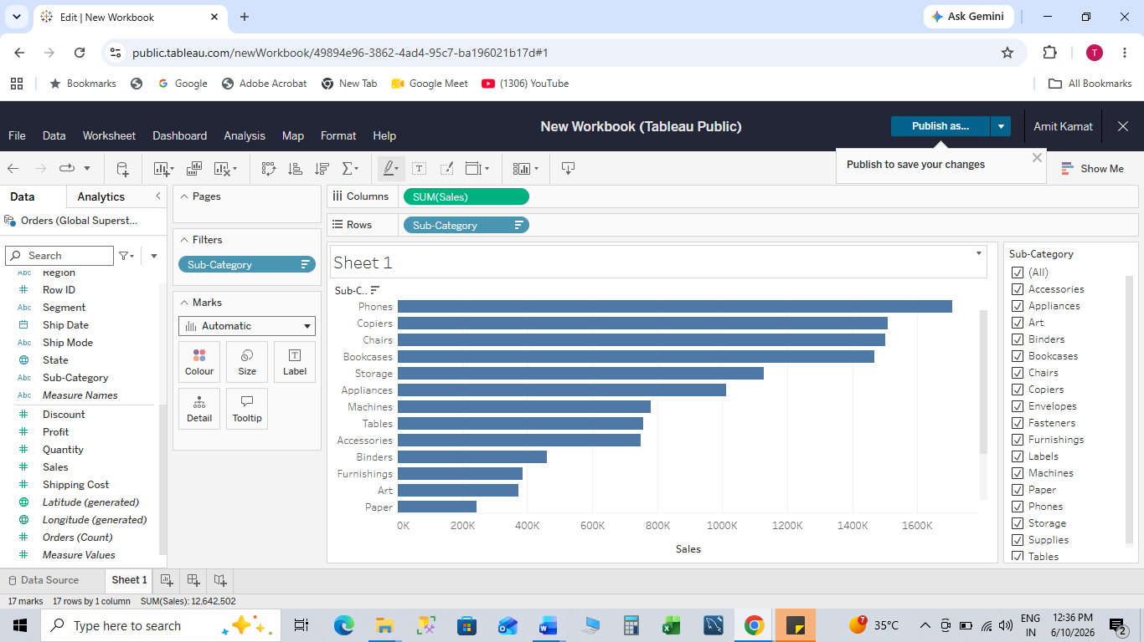
Drag Sub-Category into Filters and right click and click edit filter
Then choose Top/Bottom and then choose By field , click Ok
Step 2
In the Data Pane, right-click and select Create Parameter.
Step 3
Enter:
Option | Example
Name | Sales Target
Data Type | Float
Current Value | 50000
Display Format | Number
Step 4
Click OK.
Step 5
Right-click parameter and select Show Parameter.

Example Image
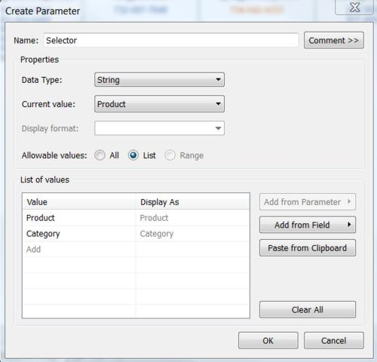
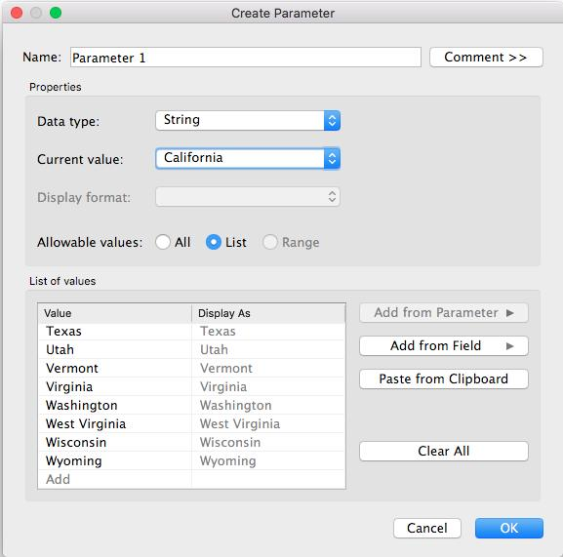
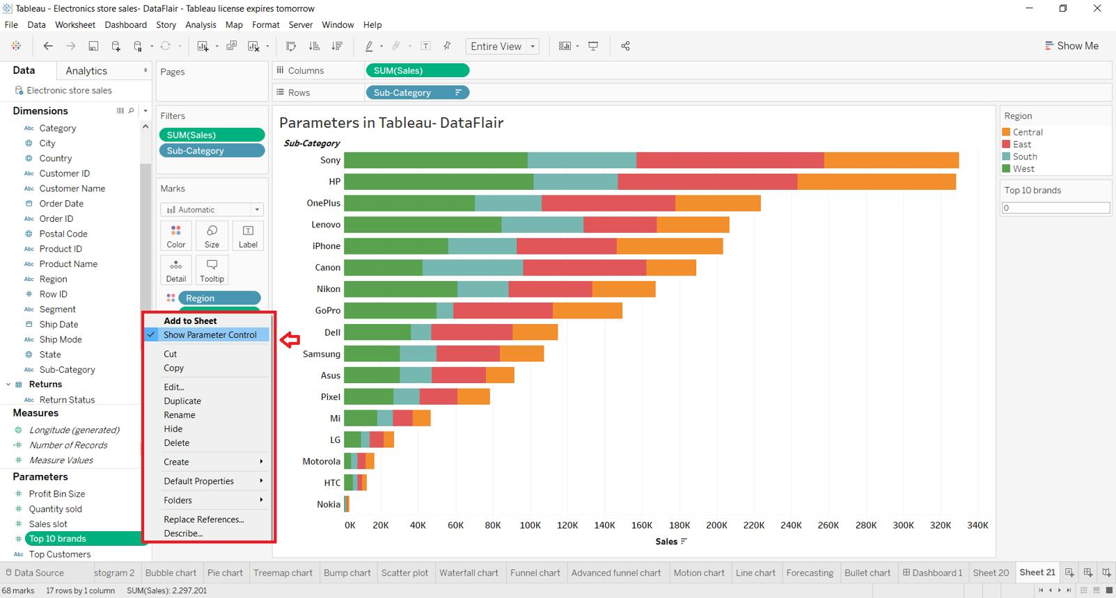

10.2 Parameters in Calculations
Parameters can be used inside calculated fields.

Example: Profit Bonus Calculation
Step 1
Create Parameter
Name:
Bonus %
Values:
5
10
15
20

Step 2
Create Calculated Field
SUM([Profit]) * ([Bonus %]/100)

Step 3
Drag calculation into worksheet.
Now users can change bonus percentage dynamically.

Example Image
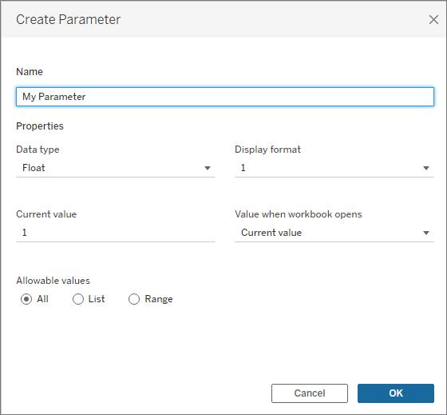
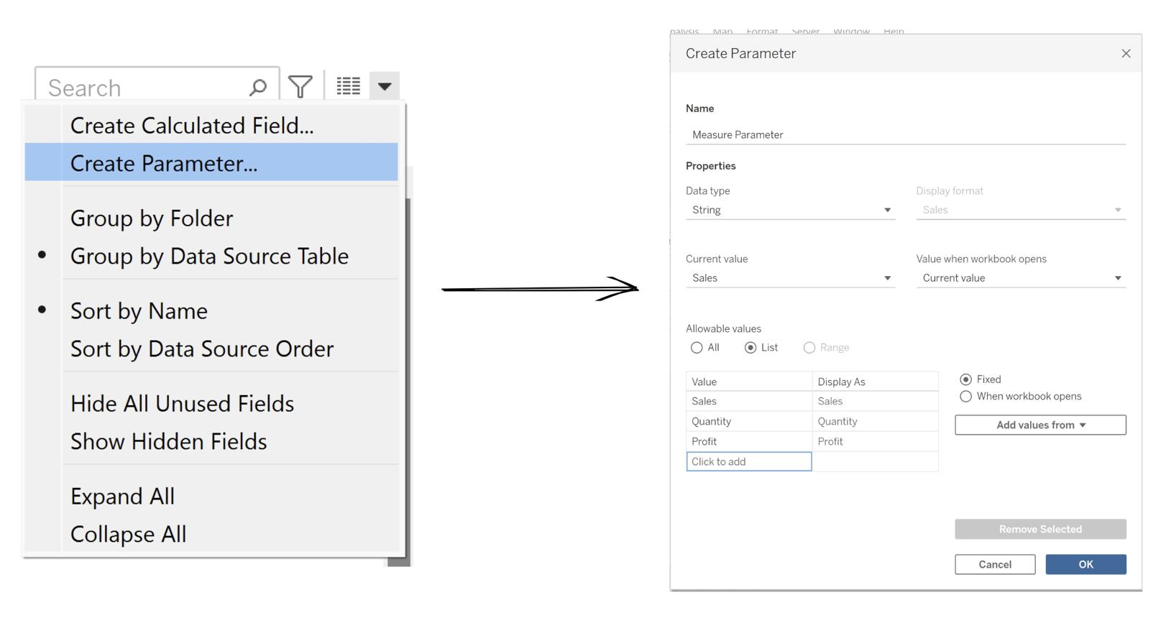
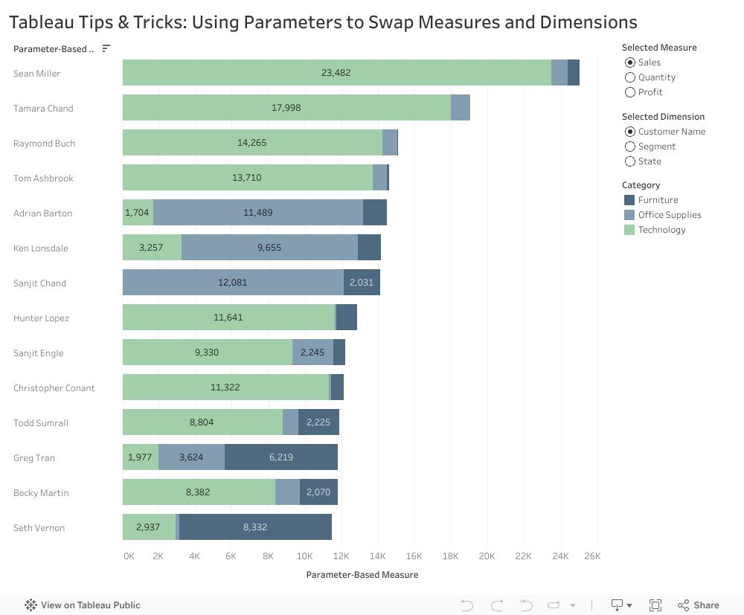
10.3 Using Parameters with Filters
Parameters can act like dynamic filters.

Example: Top N Customers
Step 1
Create Parameter
Name:
Top N
Values:
5
10
15
20

Step 2
Create Calculated Field
RANK(SUM([Sales])) <= [Top N]

Step 3
Place calculation on Filters Shelf.
Select:
True
Now users can choose Top 5, Top 10, Top 20 customers.

Example Image
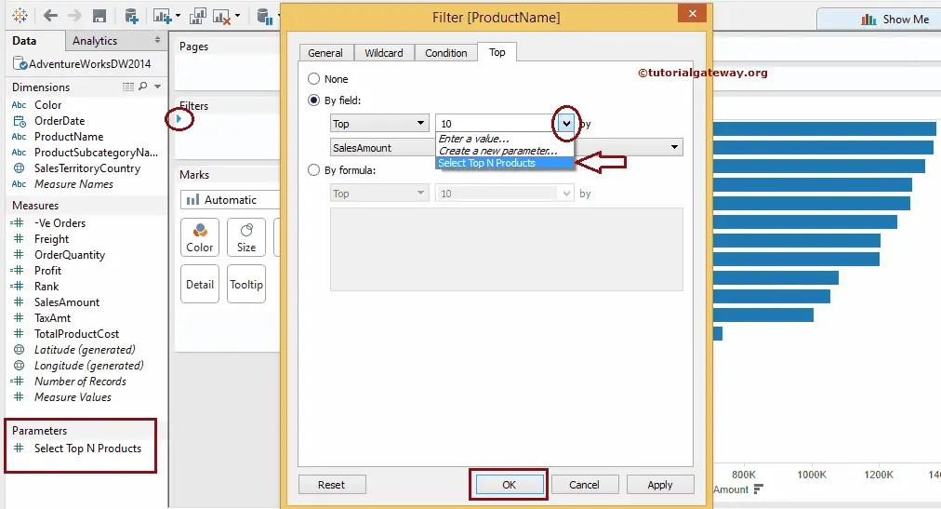
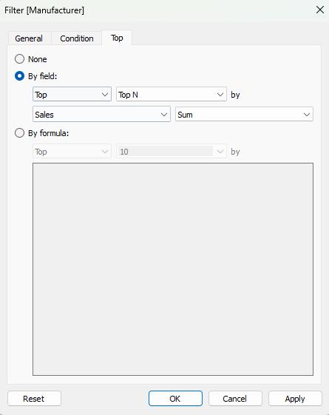
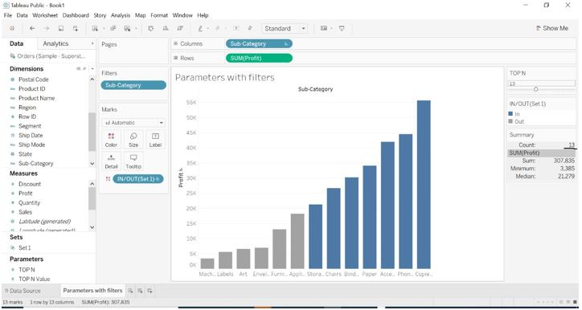

10.4 Column Selection Parameters
Allows users to switch between measures.

Example: Sales vs Profit
Step 1
Create Parameter
Name:
Measure Selector
List Values:
Sales
Profit
Quantity

Step 2
Create Calculated Field
CASE [Measure Selector]
WHEN "Sales" THEN SUM([Sales])
WHEN "Profit" THEN SUM([Profit])
WHEN "Quantity" THEN SUM([Quantity])
END

Step 3
Drag calculated field to Rows.
Users can now switch between Sales, Profit, and Quantity.

Example Image
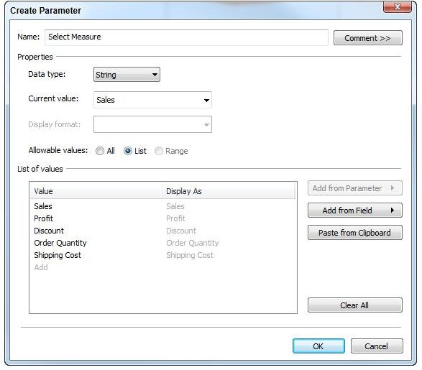
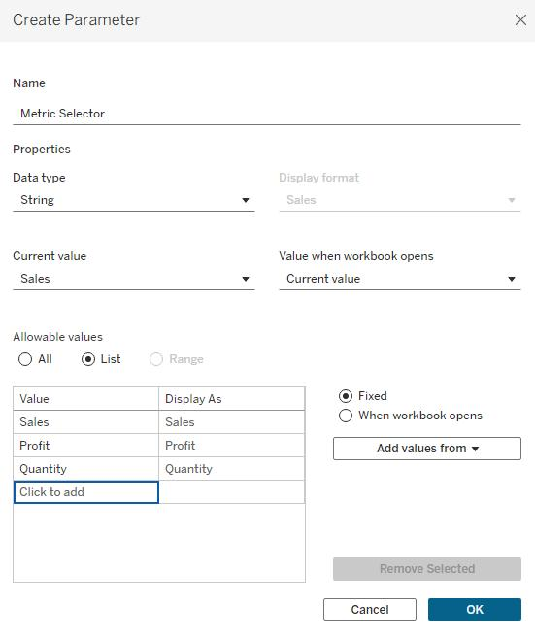
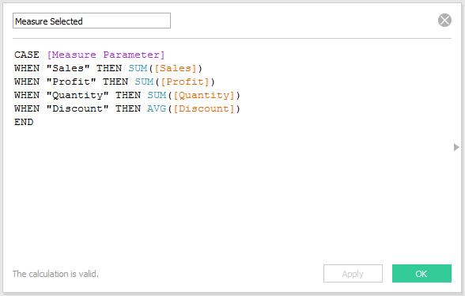

10.5 Chart Selection Parameters
Allows users to change chart types dynamically.

Example: Bar Chart vs Line Chart
Step 1
Create Parameter
Chart Type
Values:
Bar
Line

Step 2
Create Calculated Field
IF [Chart Type] = "Bar"
THEN SUM([Sales])
END
Create another field:
IF [Chart Type] = "Line"
THEN SUM([Sales])
END

Step 3
Use both fields and control visibility through parameter.

Common Uses
Parameter Value | Chart
Bar | Bar Chart
Line | Line Chart
Area | Area Chart
Scatter | Scatter Plot

Example Image
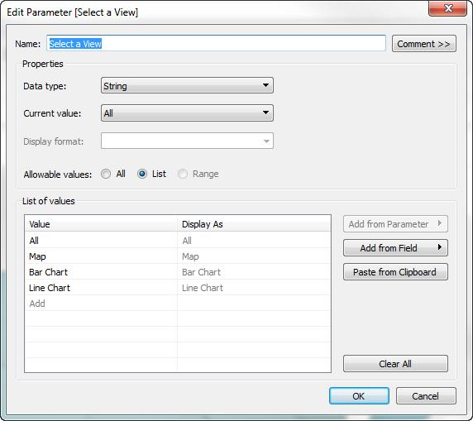
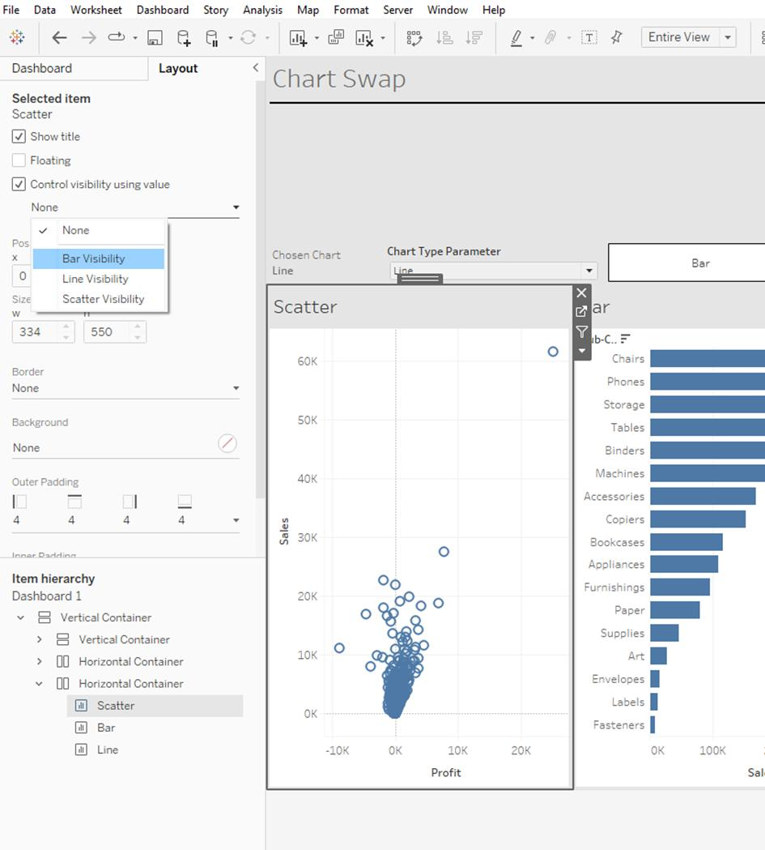
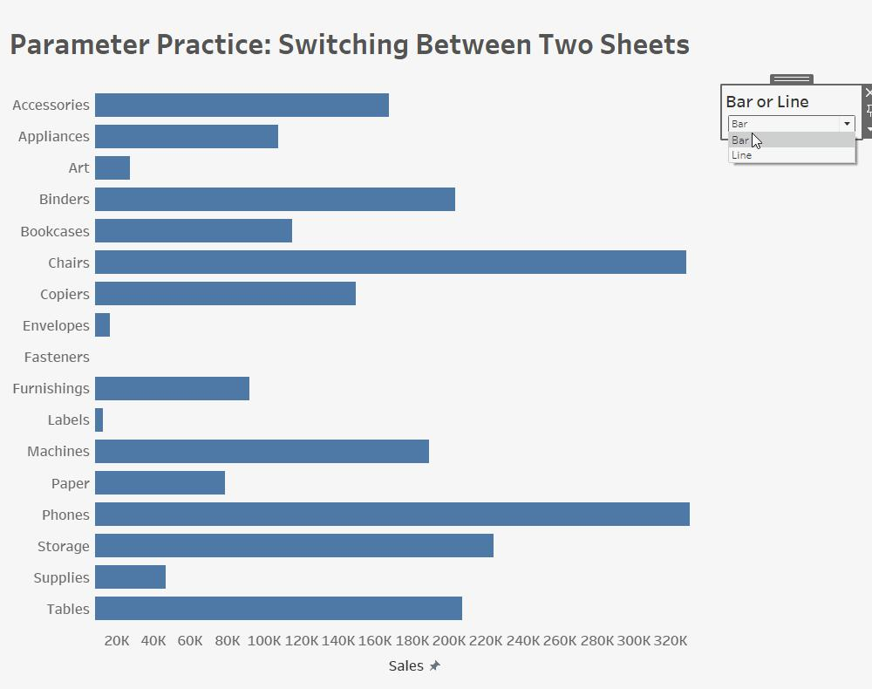

10.6 How to Use Parameters in Filter Section
Parameters can create custom filtering logic.

Example: Sales Threshold Filter
Step 1
Create Parameter
Minimum Sales
Range:
0 to 50000

Step 2
Create Calculated Field
SUM([Sales]) >= [Minimum Sales]

Step 3
Place field on Filters Shelf.
Choose:
True

Result
Users can dynamically select sales threshold.
Examples:
Parameter Value | Records Shown
1000 | Sales > 1000
5000 | Sales > 5000
10000 | Sales > 10000

Example Image
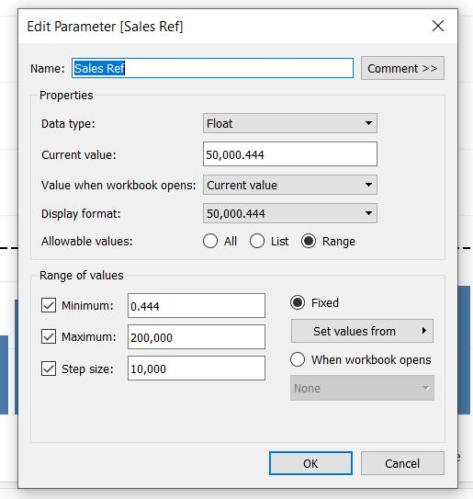

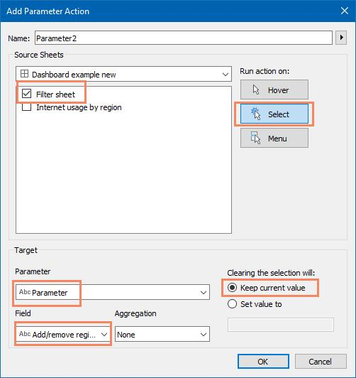

10.7 How to Use Parameters in Reference Line
Reference lines become dynamic using parameters.

Example: Sales Target Line
Step 1
Create Parameter
Sales Target
Value:
50000

Step 2
Create Calculated Field
[Sales Target]

Step 3
Right-click Axis
Select:
Add Reference Line

Step 4
Configure:
Option | Value
Scope | Entire Table
Value | Sales Target
Label | Custom

Step 5
Click OK.
A dynamic target line appears.
Users can change target anytime using parameter.
Example Image
